

|  |  |
| --- | --- |
| **Program Name and Code: CO5I** | **Academic Year : 2023-24** |
| **Course Name and Code: AJP(22517)** | **Semester : Fifth** |

**A STUDY ON**

**TIC TAC TOE GAME**

***MICRO PROJECT***

|  |  |  |  |  |
| --- | --- | --- | --- | --- |
| **Sr. No** | **Roll No (Sem-V)** | **Full name of Student** | **EnrollmentNo** | **Seat No (Sem-V)** |
| 01 | 21 | JANHVI VIJAYKUMAR KATAKDHOND | 2117340059 |  |

Under the Guidance of

**Prof. Shaikh T. A.**

in

**Three Years Diploma Programme in Engineering & Technology of Maharashtra State Board of Technical Education, Mumbai (Autonomous)**

**ISO 9001:2008 (ISO/IEC-27001:2013)**

at

**1734 – TRINITY POLYTECHNIC PUNE**



**MAHARASHTRA STATE BOARD OF TECHNICAL EDUCATION, MUMBAI**

***Certificate***

This is to certify that Ms. Janhvi Vijaykumar Katakdhond

Roll No: of **Fifth Semester** of **Diploma Programme in Engineering & Technology** at **1734 – Trinity Polytechnic Pune,**has completed the **Micro Project** satisfactorily in Subject ______________in the academic year 2022-23 as per the MSBTE prescribed curriculum of I Scheme.

Place : Pune Enrollment No: 2117340059

Date: / /2023 Exam Seat No:

# Project Guide Head of the Department Principal

**INDEX**

|  |  |  |
| --- | --- | --- |
| **Sr No.** | **Title** | **Page No.** |
| **1.** | **Abstract** | **04** |
| **2.** | **Introduction** | **06** |
| **3.** | **Source Code/Program** | **07** |
| **4.** | **Output** | **14** |
| **5.** | **Conclusion** | **16** |
| **6.** | **References** | **17** |

**Abstract**

Tic-Tac-Toe game can be played bytwo players where the squareblock (3 x 3) can be filled with a cross (X) or a circle (O). The game willtoggle between the players by giving the chance for each player to marktheir move. When one of the players make a combination of 3 samemarkers in a horizontal, vertical or diagonal line the circuit will display whichplayer has won, whether X or O.In this paper, we implement a 3x3 tic-tac-toe game on the breadboard using gates. The game is designed so thattwo players can play tic-tac-toe using button on the board that make theLED ON when respective button is pressed. The button will contain adisplay function and a select function to place the symbol as well as togglebetween the symbols allowing each player a turn to play the game. Thecircuit will update after each player makes their move and check for theconditions of game as it goes on. Overall circuit works without any bugs

* **Aims/Benefits of Microproject-**

To write a simple program to develop tic tac toe game.

* **Course Outcomes-**

1. Develop Program to develop tic tac toe game using advanced java.
2. Develop programs using AWT, Swing and Event.
3. Learn how to implement swings and events simply and successfully in program.
4. Handle events of AWT and swing components.

* **Proposed Methodology-**

First of all we searched the topic for our microprojectad finalize it.We write a simple program in advanced java develop the tic tac toe game. we write the program with the help of reference books and some other internet facilities. And find out the errors and successfully run the program.

* **Resources Required-**

|  |  |  |  |
| --- | --- | --- | --- |
| Sr. No. | Resources | Specification | Quantity |
| 1 | Computer system | Lenovo,8GB,  Windows11 | 1 |
| 2 | Software | Jdk1.8.0 | 1 |
| 3 | Internet Facilities | Chrome | 1 |

* **Rationale**-

Advanced java is an technology or advance version of java specially designedto delovlop web based and enterprise application.By using these features of advanced java like AWT, Swing and event. we created the tic toc toe game.

* **Aims/Benefits of Microproject-**

To write a simple program to develop tic tac toe game.

* **Course Outcomes Achieved-**

1. Develop Program to develop tic tac toe game using advanced java.
2. Develop programs using AWT, swing and event.
3. Learn how to implement swings and events simply and successfully in program.
4. Handle events of AWT and swing components.

* **Actual Proposed Methodology-**

First of all we searched the topic for our microprojectad finalize it.We write a simple program in advanced java develop the tic tac toe game. we write the program with the help of reference books and some other internet facilities. And find out the errors and successfully run the program.

* **Actual Resources Required-**

|  |  |  |  |
| --- | --- | --- | --- |
| Sr. No. | Resources | Specification | Quantity |
| 1 | Computer system | Lenovo,8GB,  Windows11 | 1 |
| 2 | Software | Jdk1.8.0 | 1 |
| 3 | Internet Facilities | Chrome | 1 |

* **Skills Developed-**

1. Devloped better communication skills.
2. Leadership and team work skills are developed.
3. Soft skills like self confidence and the other hand basic start up knowledge, business planning, and financial literacy.
4. Know and understood How to implement the knowledge practically.

* **Application of Microproject-**

1. Players can play the tic tac toe game.
2. To kill boredom.

**Introduction**

The Tic Tac Toe game is a game for two players, called "X" and "O", who take turns marking the spaces in a 3×3 grid. The player who succeeded in placing three respective marks in a horizontal, vertical, or diagonal row wins the game. The Tic Tac Toe is a great way to pass your free time whether you're standing in a line or spending time with your kids. Stop wasting paper and save trees. Because of the simplicity of Tic Tac Toe, it is often used as a pedagogical tool for teaching the concepts of good sportsmanship and the branch of artificial intelligence.

How to Play the Game :

* Both the players choose either X or O to mark their cells.
* There will be a 3×3 grid with numbers assigned to each of the 9 cells.
* The player who chose X begins to play first.
* He enters the cell number where he wishes to place X.
* Now, both O and X play alternatively until any one of the two wins.
* Winning criteria: Whenever any of the two players has fully filled one row/ column/ diagonal with his symbol (X/ O), he wins and the game ends.
* If neither of the two players wins, the game is said to have ended in a draw.

In this project we used advance java features like AWT, Swing, Events,etc. Because of we develop this program i.e.on mobile/Laptop for Tic tac toe game decreases the weastageof paper and ink.

**Source Code/Program**

import java.awt.*;

import java.awt.event.*;

import java.util.*;

import javax.swing.*;

public class TicTacToeGame implements ActionListener

{

JFrame frame = new JFrame();

JPanel t_panel = new JPanel();

JPanel bt_panel = new JPanel();

JLabel textfield = new JLabel();

JButton[] bton = new JButton[9];

int chance_flag = 0;

Random random = new Random();

boolean pl1_chance;

TicTacToeGame()

{

frame.setDefaultCloseOperation(JFrame.EXIT_ON_CLOSE);

frame.setSize(800, 800);

frame.getContentPane().setBackground(new Color(50, 50, 50));

frame.setTitle("Tic Tac Toe");

frame.setLayout(new BorderLayout());

frame.setVisible(true);

textfield.setBackground(new Color(120, 20, 124));

textfield.setForeground(new Color(25, 255, 0));

textfield.setFont(new Font("Ink Free", Font.BOLD, 75));

textfield.setHorizontalAlignment(JLabel.CENTER);

textfield.setText("Tic Tac Toe");

textfield.setOpaque(true);

t_panel.setLayout(new BorderLayout());

t_panel.setBounds(0, 0, 800, 100);

bt_panel.setLayout(new GridLayout(3, 3));

bt_panel.setBackground(new Color(150, 150, 150));

for (int i = 0; i < 9; i++) {

bton[i] = new JButton();

bt_panel.add(bton[i]);

bton[i].setFont(new Font("Ink Free", Font.BOLD, 120));

bton[i].setFocusable(false);

bton[i].addActionListener(this);

}

t_panel.add(textfield);

frame.add(t_panel, BorderLayout.NORTH);

frame.add(bt_panel);

startGame();

}

public void startGame() {

try {

textfield.setText("Loading....");

Thread.sleep(4000);

} catch (InterruptedException e) {

e.printStackTrace();

}

int chance=random.nextInt(100);

if (chance%2 == 0) {

pl1_chance = true;

textfield.setText("X turn");

} else {

pl1_chance = false;

textfield.setText("O turn");

}

}

public void gameOver(String s){

chance_flag = 0;

Object[] option={"Restart","Exit"};

int n=JOptionPane.showOptionDialog(frame, "Game Over\n"+s,"Game Over",JOptionPane.YES_NO_CANCEL_OPTION,JOptionPane.QUESTION_MESSAGE,null,option,option[0]);

if(n==0){

frame.dispose();

new TicTacToeGame();

}

else{

frame.dispose();

}

}

public void matchCheck() {

if ((bton[0].getText() == "X") && (bton[1].getText() == "X") && (bton[2].getText() == "X")) {

xWins(0, 1, 2);

}

else if ((bton[0].getText() == "X") && (bton[4].getText() == "X") && (bton[8].getText() == "X")) {

xWins(0, 4, 8);

}

else if ((bton[0].getText() == "X") && (bton[3].getText() == "X") && (bton[6].getText() == "X")) {

xWins(0, 3, 6);

}

else if ((bton[1].getText() == "X") && (bton[4].getText() == "X") && (bton[7].getText() == "X")) {

xWins(1, 4, 7);

}

else if ((bton[2].getText() == "X") && (bton[4].getText() == "X") && (bton[6].getText() == "X")) {

xWins(2, 4, 6);

}

else if ((bton[2].getText() == "X") && (bton[5].getText() == "X") && (bton[8].getText() == "X")) {

xWins(2, 5, 8);

}

else if ((bton[3].getText() == "X") && (bton[4].getText() == "X") && (bton[5].getText() == "X")) {

xWins(3, 4, 5);

}

else if ((bton[6].getText() == "X") && (bton[7].getText() == "X") && (bton[8].getText() == "X")) {

xWins(6, 7, 8);

}

else if ((bton[0].getText() == "O") && (bton[1].getText() == "O") && (bton[2].getText() == "O")) {

oWins(0, 1, 2);

}

else if ((bton[0].getText() == "O") && (bton[3].getText() == "O") && (bton[6].getText() == "O")) {

oWins(0, 3, 6);

}

else if ((bton[0].getText() == "O") && (bton[4].getText() == "O") && (bton[8].getText() == "O")) {

oWins(0, 4, 8);

}

else if ((bton[1].getText() == "O") && (bton[4].getText() == "O") && (bton[7].getText() == "O")) {

oWins(1, 4, 7);

}

else if ((bton[2].getText() == "O") && (bton[4].getText() == "O") && (bton[6].getText() == "O")) {

oWins(2, 4, 6);

}

else if ((bton[2].getText() == "O") && (bton[5].getText() == "O") && (bton[8].getText() == "O")) {

oWins(2, 5, 8);

}

else if ((bton[3].getText() == "O") && (bton[4].getText() == "O") && (bton[5].getText() == "O")) {

oWins(3, 4, 5);

} else if ((bton[6].getText() == "O") && (bton[7].getText() == "O") && (bton[8].getText() == "O")) {

oWins(6, 7, 8);

}

else if(chance_flag==9) {

textfield.setText("Match Tie");

gameOver("Match Tie");

}

}

public void xWins(int x1, int x2, int x3)

{

bton[x1].setBackground(Color.RED);

bton[x2].setBackground(Color.RED);

bton[x3].setBackground(Color.RED);

for (int i = 0; i < 9; i++) {

bton[i].setEnabled(false);

}

textfield.setText("X wins");

gameOver("X Wins");

}

public void oWins(int x1, int x2, int x3) {

bton[x1].setBackground(Color.RED);

bton[x2].setBackground(Color.RED);

bton[x3].setBackground(Color.RED);

for (int i = 0; i < 9; i++) {

bton[i].setEnabled(false);

}

textfield.setText("O Wins");

gameOver("O Wins");

}

@Override

public void actionPerformed(ActionEvent e) {

for (int i = 0; i < 9; i++) {

if (e.getSource() == bton[i]) {

if (pl1_chance) {

if (bton[i].getText() == "") {

bton[i].setForeground(new Color(255, 0, 0));

bton[i].setText("X");

pl1_chance = false;

textfield.setText("O turn");

chance_flag++;

matchCheck();

}

} else {

if (bton[i].getText() == "") {

bton[i].setForeground(new Color(0, 0, 255));

bton[i].setText("O");

pl1_chance = true;

textfield.setText("X turn");

chance_flag++;

matchCheck();

}

} } } }

public static void main(String args[])

{

TicTacToeGame t1=new TicTacToeGame();

}

}

**Output**

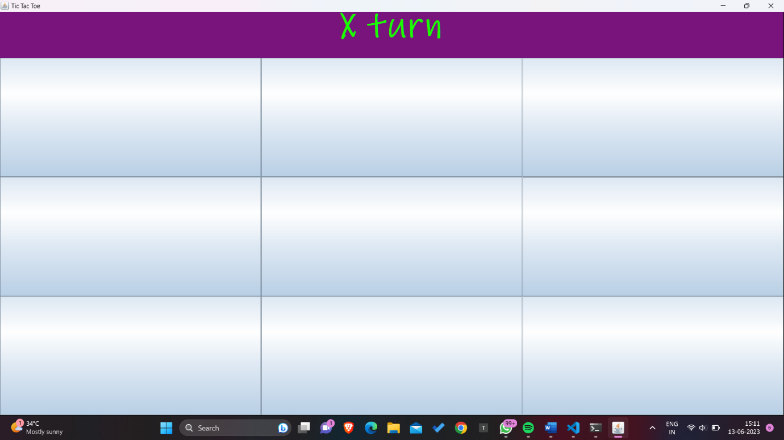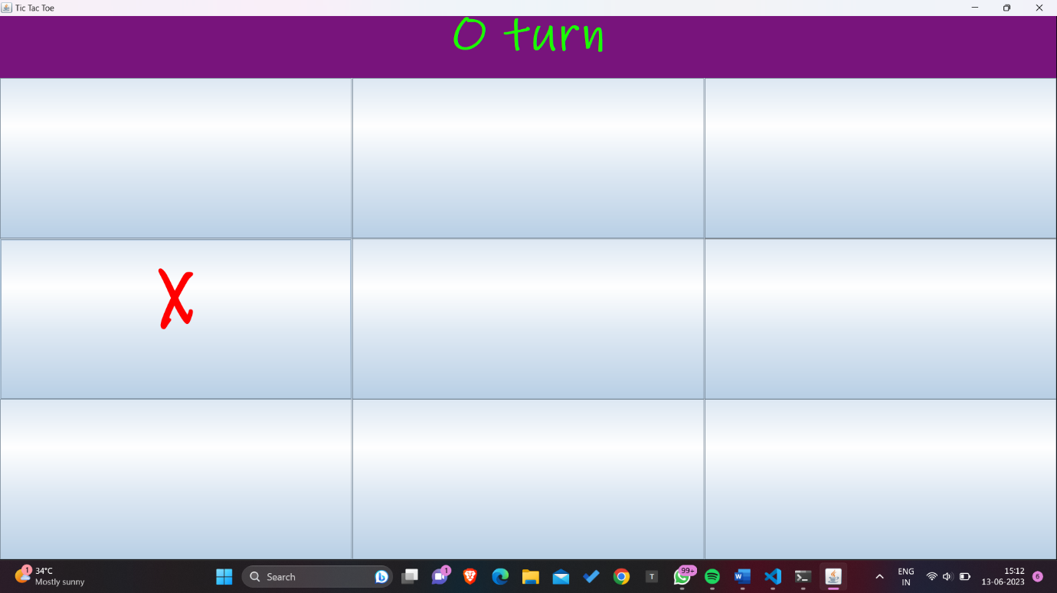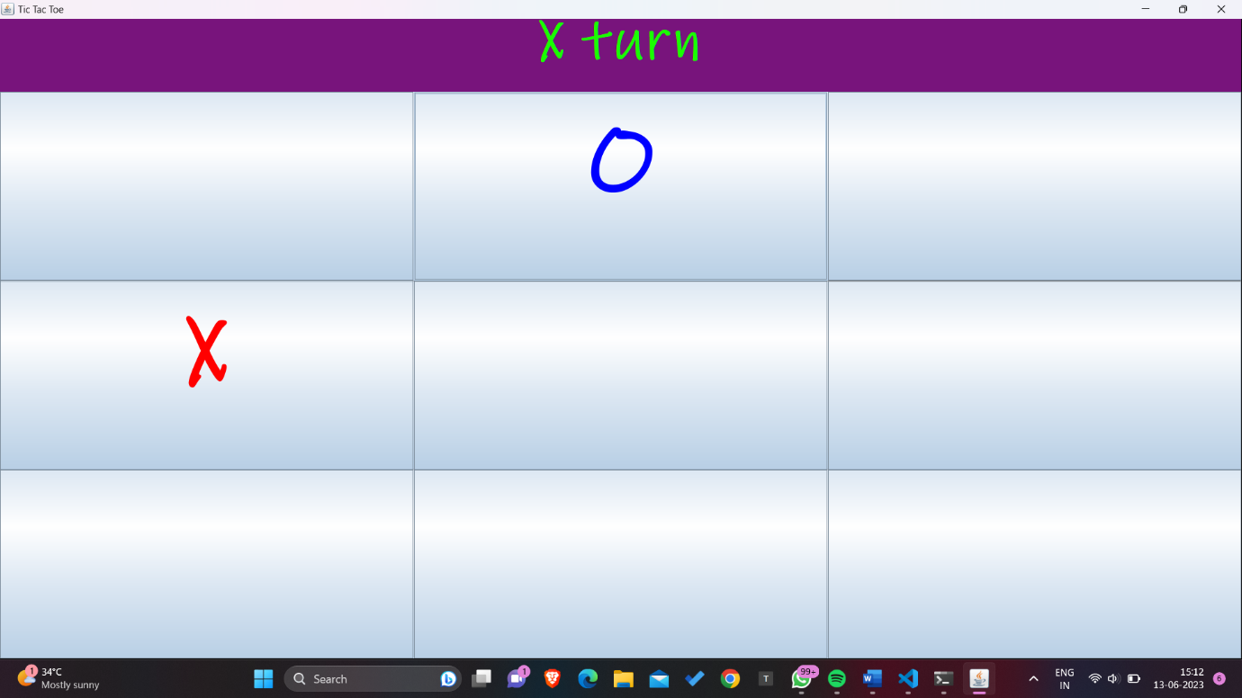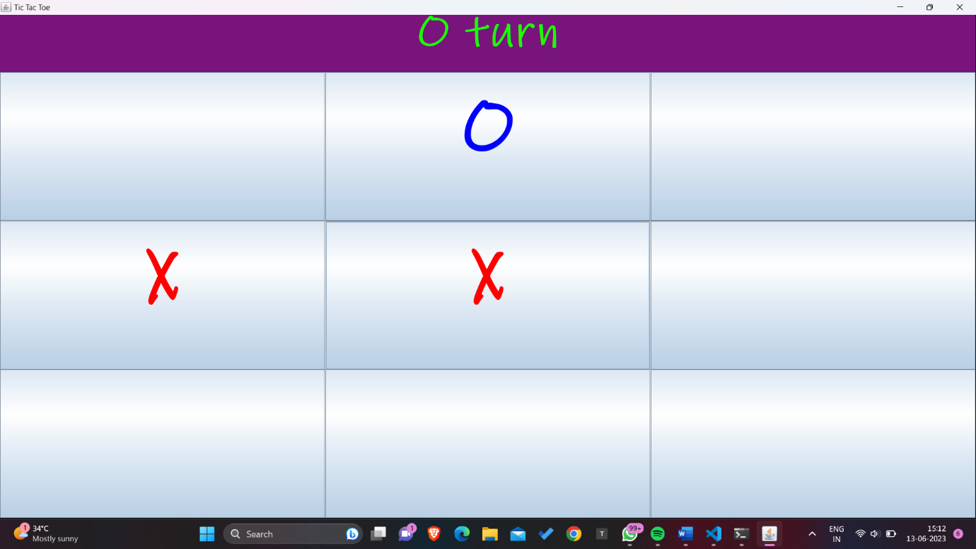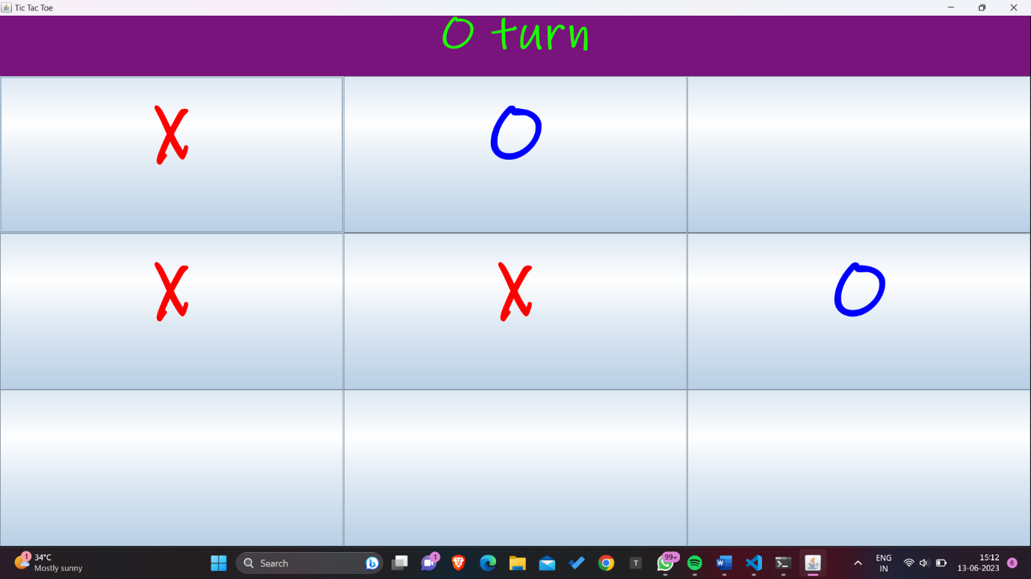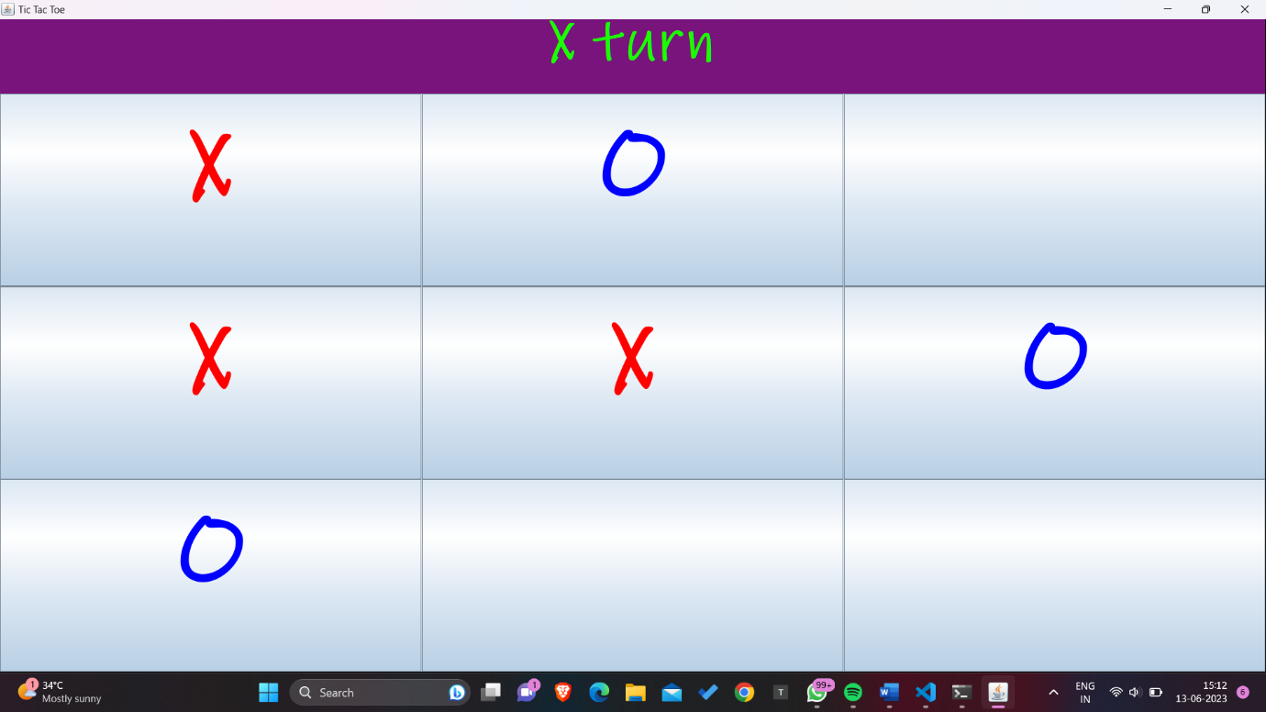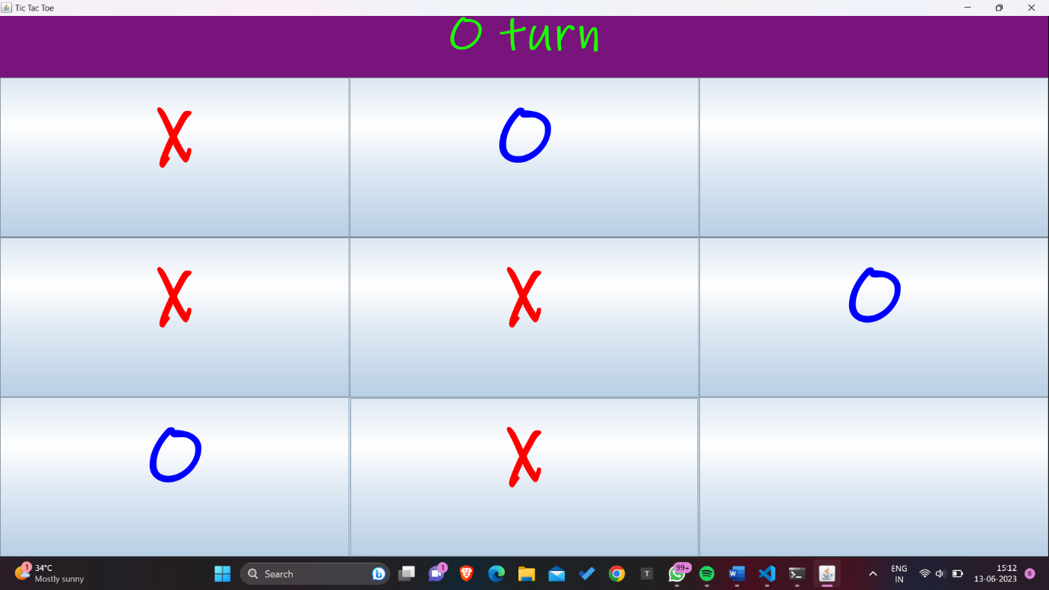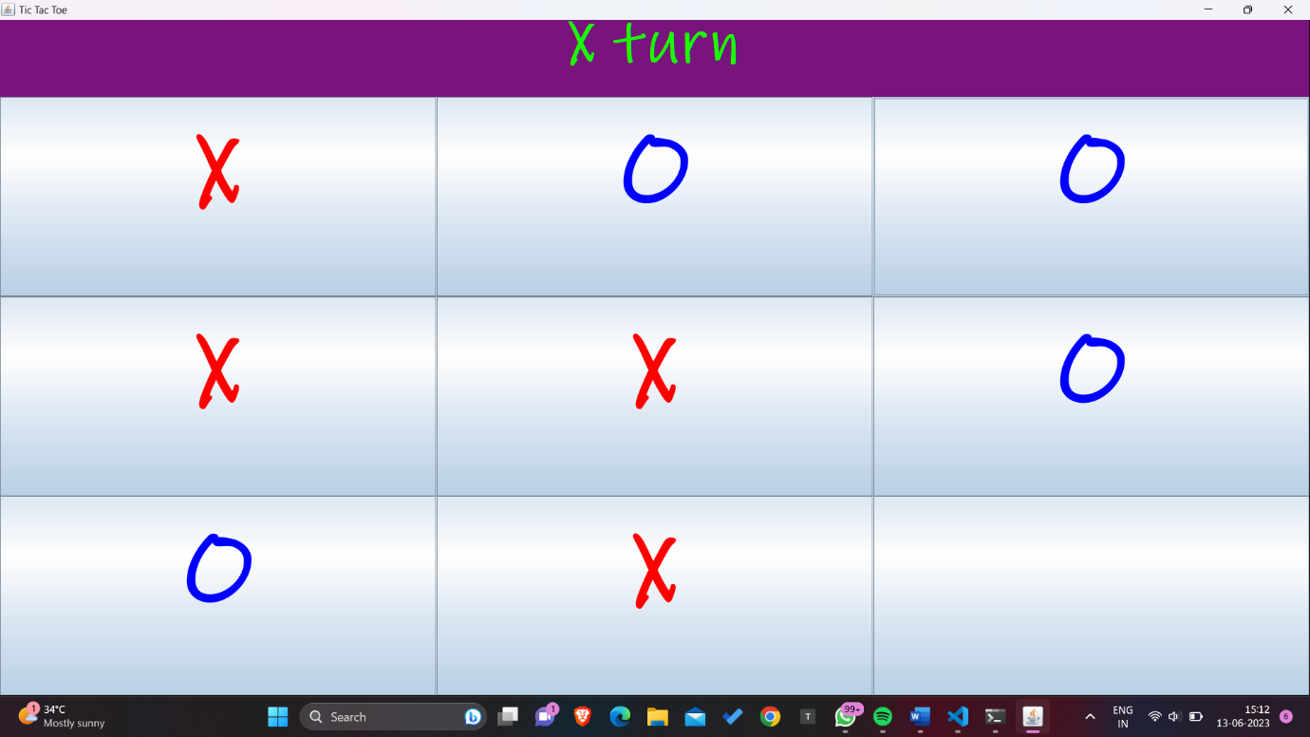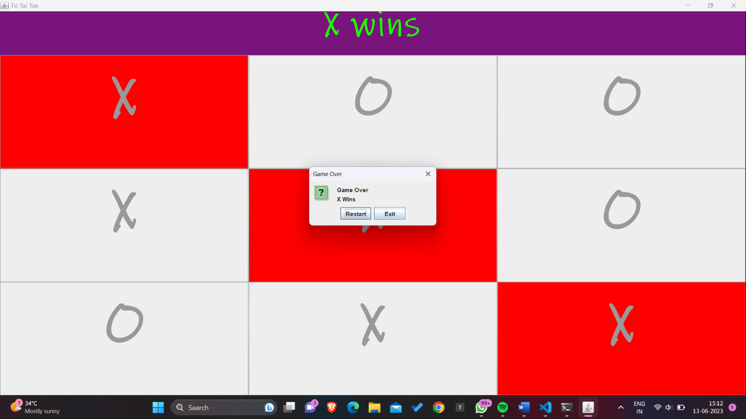

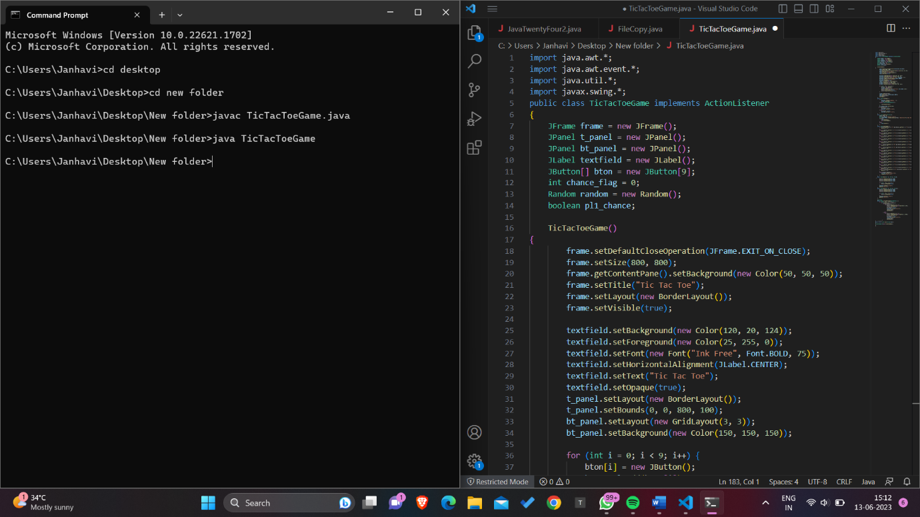

**Conclusion**

Our microproject will be able to implement in future after making some changes and modifications with developing technologies. So the modifications that can be done in our project are:

In future one change can be done by adding the fingerprints of the person of which the address is entered. And one more major change which can be done in this project is that to add snaps of the person of which the address is entered. We can also add or substract details of the individual and more. We can use Css, Andriod,Database based languages, Javascript,etc for make the application of Tic tac toe game.

**References**

* [Java Tutorial | Learn Java Programming - javatpoint](https://www.javatpoint.com/java-tutorial)